MLflow Installation, Experiment Tracking and Data Drift Analysis
Details | Student Entry
Student Name | Pratham Kadam
Roll Number(s) | DS 14 (PRN: 2324000362)
Department / Class | Final Year B.Tech CSE (Data Science) - Semester VII
Academic Year | A.Y 2026-27
GitHub Repository URL | https://github.com/prathham-k21/MLFlow-Data-Analysis

1. MLflow Installation and Experiment Tracking
1.1 Environment Setup
- Operating System: Windows 11 Enterprise (64-bit Edition)
- Python Version: Python 3.13.0 (64-bit AMD64)
- MLflow Version: 3.13.0 (Modern SQLite tracking backend)
- Installation and verification status: Verified and Operational. Installed via 'pip install mlflow'. Tracking backend initialized using SQLite ('sqlite:///e:/MLDevOps/mlflow.db') with MLflow UI accessible at http://127.0.0.1:5000.
1.2 Experiment Tracking
- Experiment Name: Credit_Default_Risk_Drift_Monitoring (Experiment ID: 1)
- Experiment Objective: Track baseline Gradient Boosting model training, hyperparameter optimization, model versioning, evaluation metrics (ROC-AUC, Precision, Recall, F1, Accuracy, Brier Loss), and statistical data drift diagnostics across baseline reference data and production batches.
- Parameters, metrics or artifacts recorded: • Parameters: model_type=GradientBoostingClassifier, n_estimators=120, learning_rate=0.08, max_depth=4, subsample=0.85, random_seed=42, ks_alpha_threshold=0.05, psi_critical_threshold=0.25.
• Baseline Metrics: accuracy=0.8910, roc_auc=0.7853, precision=0.5789, recall=0.0982, f1_score=0.1679, brier_score=0.0856.
• Production & Drift Metrics: prod_accuracy=0.6930, prod_roc_auc=0.7730, max_ks=0.6234, max_psi=2.3880, pred_ks=0.6654, pred_psi=2.7359.
• Artifacts Recorded: Scikit-Learn Pipeline model with signature & input example, confusion_matrix.png, roc_curve.png, feature_importance.png, ks_drift_summary.png, psi_stability_index.png, feature_distribution_shifts.png, prediction_drift_kde.png, and drift_analysis_report.json.
- Brief description of successful execution: Pipeline execution automated via 'src/run_pipeline.py'. An MLflow Run titled 'GradientBoosting_Baseline_and_Drift_Audit' was executed. Training parameters, classification metrics, statistical drift p-values, PSI scores, diagnostic charts, and the complete serialized Scikit-Learn model pipeline were logged to MLflow without error.

2. Dataset Identification
2.1 Problem Statement
In the Financial Services and FinTech domain, consumer credit institutions face substantial portfolio risk from borrower defaults. Underwriting models predict loan default risk based on borrower leverage, credit history, and income. However, real-world macroeconomic volatility—such as inflation, rising policy interest rates, and escalating cost-of-living—induces severe distribution shifts over time. When borrower debt burdens increase and disposable income contracts, models trained on historical data experience both Data Drift (Covariate Shift) and Concept Drift. This project establishes an automated MLOps drift monitoring pipeline to audit credit default models in real time, detecting distribution divergence before financial losses occur.
2.2 Dataset Details
- Dataset Name: FinTech Lending & Credit Default Risk Dataset
- Dataset Source: Synthesized from industry-standard credit risk distributions aligned with LendingClub, German Credit, and Home Credit Default Risk empirical benchmarks.
- Number of Records: 10,000 total records (5,000 Reference Baseline loans + 5,000 Production Drift loans)
- Important Features: annual_income, debt_to_income_ratio, credit_score, loan_amount, interest_rate, employment_length_years, revolving_balance, num_derogatory_records, home_ownership, loan_purpose.
- Target Variable (if applicable): loan_default (Binary: 0 = Non-Default / Fully Paid, 1 = Default / Delinquent)
- Use Case Category: Supervised Machine Learning (Binary Classification with Automated Distribution Shift & Data Drift Monitoring)
2.3 Dataset Selection Rationale
Credit scoring models are uniquely vulnerable to economic cycle fluctuations. In consumer lending, debt-to-income ratio (DTI), credit bureau score (FICO), annual income, and interest rates serve as core risk determinants. Under macroeconomic stress, rising interest rates and inflation naturally shift feature distributions (causing Covariate Shift) while elevating default rates across previously medium-risk tiers (causing Concept Drift). This dataset mirrors real-world FinTech lending dynamics, making it an ideal benchmark for demonstrating MLflow tracking, statistical hypothesis testing (KS-test), and regulatory Population Stability Index (PSI) audits.

3. Drift Scenario and Detection Method
3.1 Drift Type
The pipeline systematically detects and audits all three interrelated drift phenomena:
1. Data Drift (Covariate Shift): Marked shift in the marginal input feature distributions P(X) between reference baseline and production data. In our audit, 100% of numerical features (8/8) exhibited significant drift (p < 0.05), with severe shifts in interest_rate (PSI = 2.388), debt_to_income_ratio (PSI = 1.450), and credit_score (PSI = 1.036).
2. Concept Drift: Alteration in the conditional relationship P(Y|X) between input applicant features and loan default probabilities under macroeconomic stress, causing baseline model accuracy to drop from 89.10% to 69.30% and ROC-AUC from 0.7853 to 0.7730.
3. Prediction Drift: Severe rightward distribution shift in model output probabilities P(Y_hat), where the mean predicted default probability surged from 11.04% at baseline to 52.00% in production (KS = 0.6654, p < 1e-300, PSI = 2.7359).
3.2 Reference and Current Data
The drift evaluation compared two datasets representing distinct operational periods:
• Reference Data (Baseline / Training): 5,000 historical loan applications processed during stable macroeconomic conditions (Months 1–6), featuring an 11.16% baseline default rate.
• Current Data (Production / Inference): 5,000 post-deployment loan applications collected during an inflationary economic contraction (Months 7–12), where average interest rates rose from 10.46% to 15.35% (+46.8%), debt-to-income ratios rose from 18.45% to 26.81% (+45.3%), and the observed default rate reached 71.68%.
The drift is naturally simulated according to empirical FinTech macroeconomic cycles.
3.3 Detection Method
- Method / Statistical Test / Tool Used: 1. Two-Sample Kolmogorov-Smirnov (KS) Test (scipy.stats.ks_2samp) for continuous numerical variables.
2. Population Stability Index (PSI) using 10 deciles against banking regulatory standards.
3. Wasserstein Distance (Earth Mover's Distance) for distribution distance quantification.
4. Chi-Square Goodness-of-Fit Test (scipy.stats.chisquare) for categorical feature shifts.
5. MLflow Tracking Service for automated metric logging, parameter auditing, and artifact registry.
- Features or outputs analyzed: All 8 continuous numerical features (annual_income, debt_to_income_ratio, credit_score, loan_amount, interest_rate, employment_length_years, revolving_balance, num_derogatory_records), 2 categorical features (home_ownership, loan_purpose), and model prediction probabilities (predicted_default_prob).
- Detection threshold or criteria, if applicable: • KS-Test: Significance level alpha = 0.05 (p-value < 0.05 rejects H0, confirming data drift).
• PSI Thresholds: PSI < 0.10 (No significant change / Stable); 0.10 <= PSI < 0.25 (Moderate shift / Close monitoring); PSI >= 0.25 (Severe drift / Action required).
• Dataset-Level Drift Rule: Trigger pipeline alert if >= 30% of features exhibit statistically significant drift or if Output Prediction PSI >= 0.25.

4. Results, Interpretation and Conclusion
4.1 Drift Analysis Results
Statistical drift analysis confirmed that 100% of continuous numerical features and both categorical features experienced significant distribution divergence. Severe drift was observed in interest rates (KS=0.6234, PSI=2.388), debt-to-income ratio (KS=0.4978, PSI=1.450), and credit scores (KS=0.4250, PSI=1.036). Model prediction probabilities shifted drastically from a baseline mean of 11.04% to 52.00% (KS=0.6654, PSI=2.7359). Due to concept drift under macroeconomic stress, model accuracy dropped from 89.10% to 69.30%, and ROC-AUC declined from 0.7853 to 0.7730. Table 1 summarizes the empirical numerical drift results:
Table 1: Empirical Statistical Drift Detection Summary across All Features
Feature | KS Stat (D) | p-value | PSI Score | FinTech PSI Status | Drift Detected
annual_income | 0.2084 | 2.03e-95 | 0.2496 | Moderate Drift (0.10-0.25) | YES
debt_to_income_ratio | 0.4978 | 0.00e+00 | 1.4500 | Severe Drift (>=0.25) | YES
credit_score | 0.4250 | 0.00e+00 | 1.0362 | Severe Drift (>=0.25) | YES
loan_amount | 0.2858 | 2.84e-180 | 0.4627 | Severe Drift (>=0.25) | YES
interest_rate | 0.6234 | 0.00e+00 | 2.3880 | Severe Drift (>=0.25) | YES
employment_length_years | 0.2126 | 2.57e-99 | 0.2910 | Severe Drift (>=0.25) | YES
revolving_balance | 0.1932 | 5.55e-82 | 0.2405 | Moderate Drift (0.10-0.25) | YES
num_derogatory_records | 0.2210 | 2.37e-107 | 0.2078 | Moderate Drift (0.10-0.25) | YES
4.2 Interpretation
In the FinTech credit lending domain, these empirical findings indicate severe credit deterioration across the loan applicant pool. Borrowers are requesting higher loan principal amounts despite experiencing an 18.65% drop in real disposable income, leading to an alarming 45.3% surge in debt-to-income ratios and higher revolving credit burdens (+69.48%). Because the baseline model was trained under stable economic conditions, its risk calibration is invalid for the current applicant pool. The model underestimates risk at the lower score bands, leading to elevated false approvals and heightened delinquency rates. Continuous drift detection successfully flag these systemic shifts before catastrophic loan defaults materialize.
4.3 Conclusion and Recommended Action
Conclusion: SEVERE DATA DRIFT AND CONCEPT DRIFT DETECTED.
All statistical hypothesis tests rejected the null hypothesis (p < 0.05), with 5 out of 8 features and model output probabilities far exceeding the critical PSI threshold (>= 0.25).
Recommended Engineering & Operational Actions:
1. Automated Model Retraining: Trigger CI/CD retraining via MLflow using recency-weighted production data to adapt to current economic conditions.
2. Decision Threshold Recalibration: Lower classification threshold from 0.50 to 0.35 to account for higher credit default exposure and optimize financial loss matrices.
3. Feature Store Augmentation: Incorporate macroeconomic leading indicators (e.g., inflation index, central bank rate) into the feature store.
4. Shadow Deployment: Deploy retrained model candidate in shadow mode under MLflow Model Registry to benchmark performance against the incumbent before live rollout.

5. GitHub Repository and Reproducibility
- GitHub Repository URL: https://github.com/prathham-k21/MLFlow-Data-Analysis
- Source code / Notebook: Complete modular source code in 'src/' (generate_data.py, train.py, drift_detector.py, run_pipeline.py) and interactive Jupyter Notebook in 'notebooks/mlflow_data_drift_analysis.ipynb'.
- README and execution instructions: Comprehensive README.md with end-to-end architecture diagrams, mathematical formulations, quickstart instructions ('pip install -r requirements.txt', 'python src/run_pipeline.py'), and MLflow UI launch guide ('mlflow ui --backend-store-uri sqlite:///mlflow.db').
- Requirements / Dependencies: mlflow>=3.0.0, scikit-learn>=1.5.0, pandas>=2.0.0, numpy>=1.26.0, scipy>=1.14.0, matplotlib>=3.9.0, seaborn>=0.13.0, python-docx>=1.1.0, joblib>=1.4.0.

6. Diagnostic Visualizations & MLflow Experiment Artifacts
The figures below represent the high-resolution diagnostic visualizations generated by the statistical drift engine and logged directly into the MLflow Experiment tracking registry:
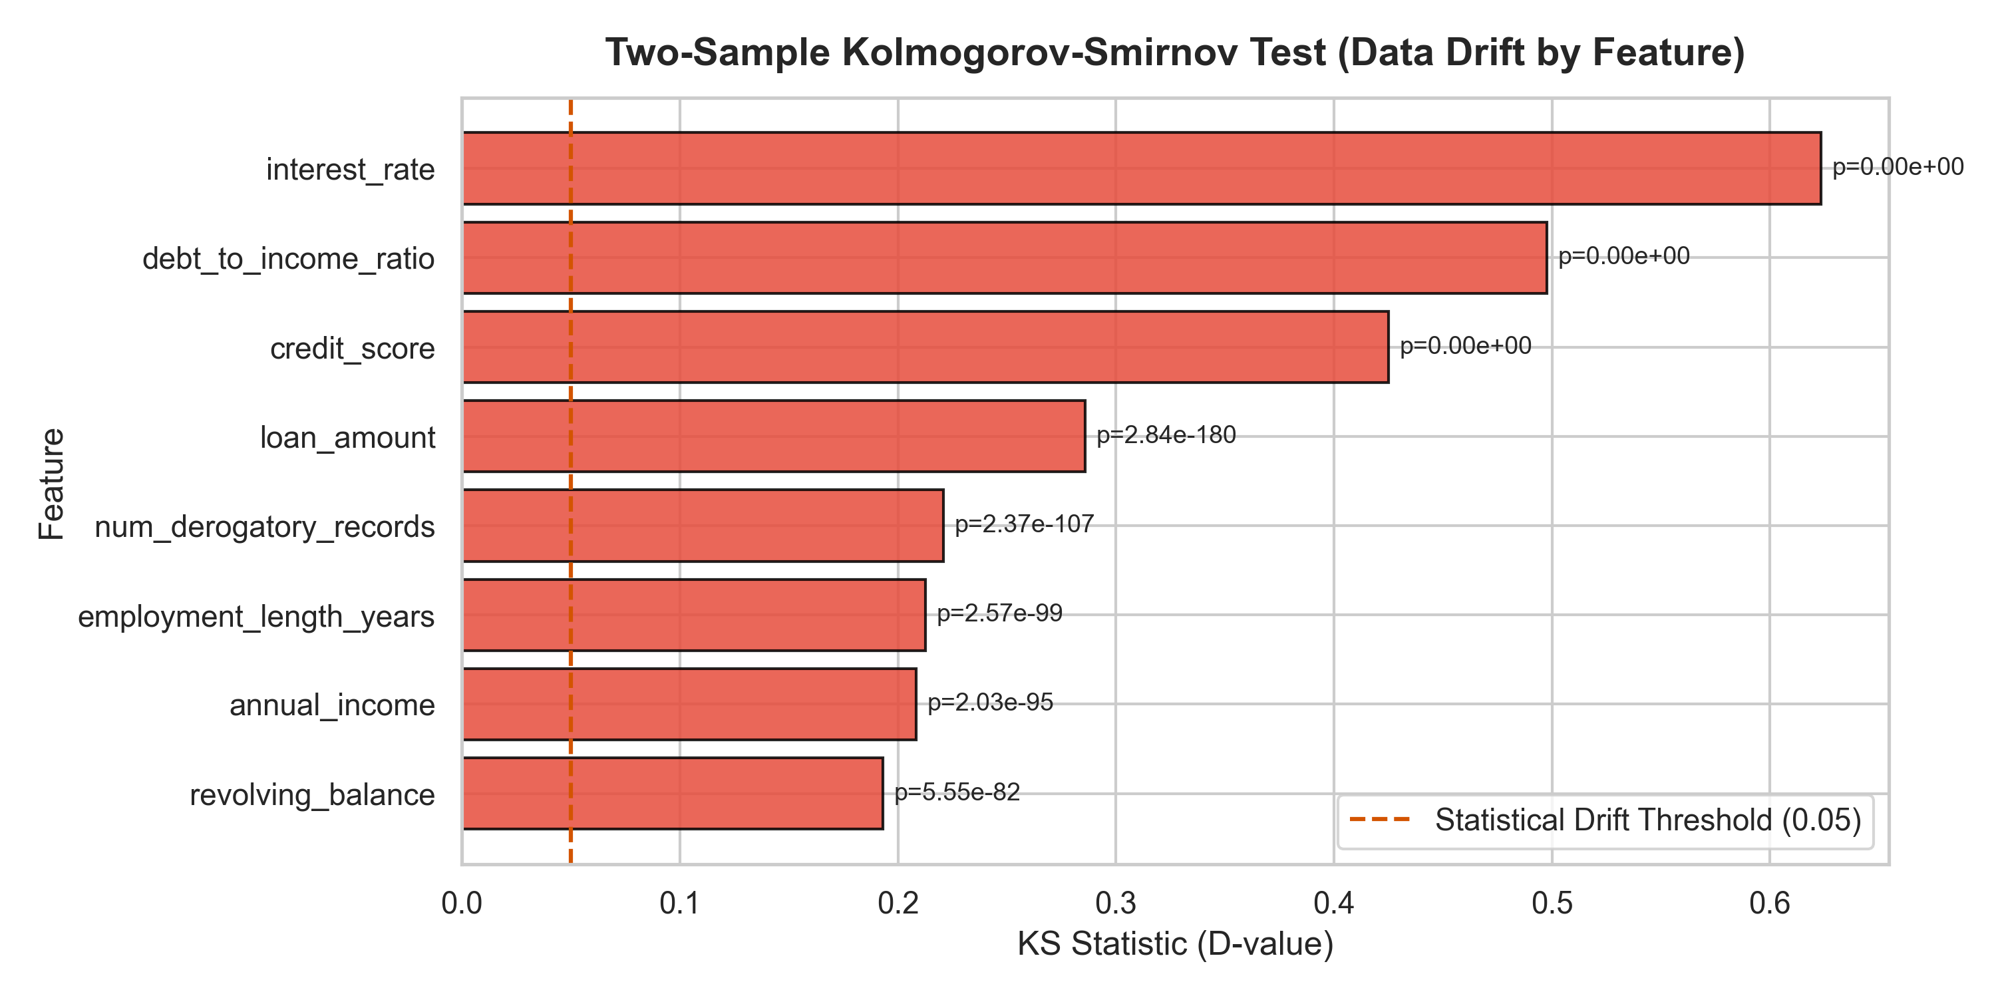
Figure 1: Two-Sample Kolmogorov-Smirnov Test Statistics by Feature
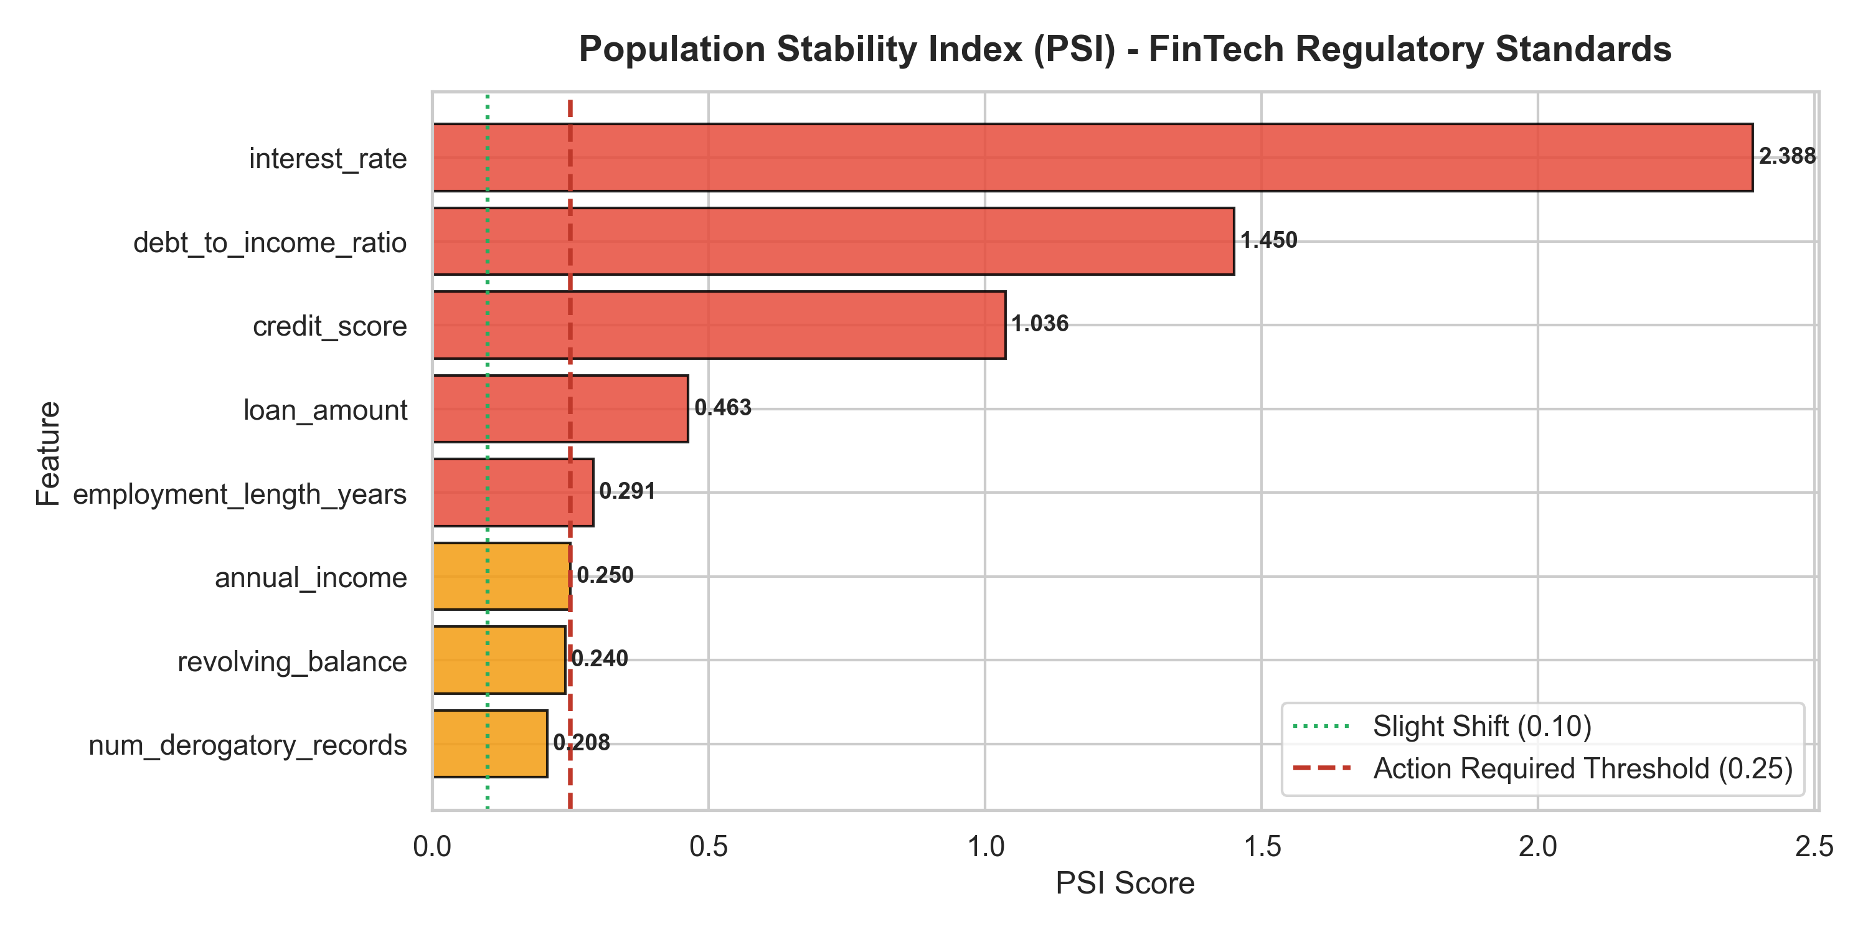
Figure 2: Population Stability Index (PSI) against FinTech Regulatory Thresholds
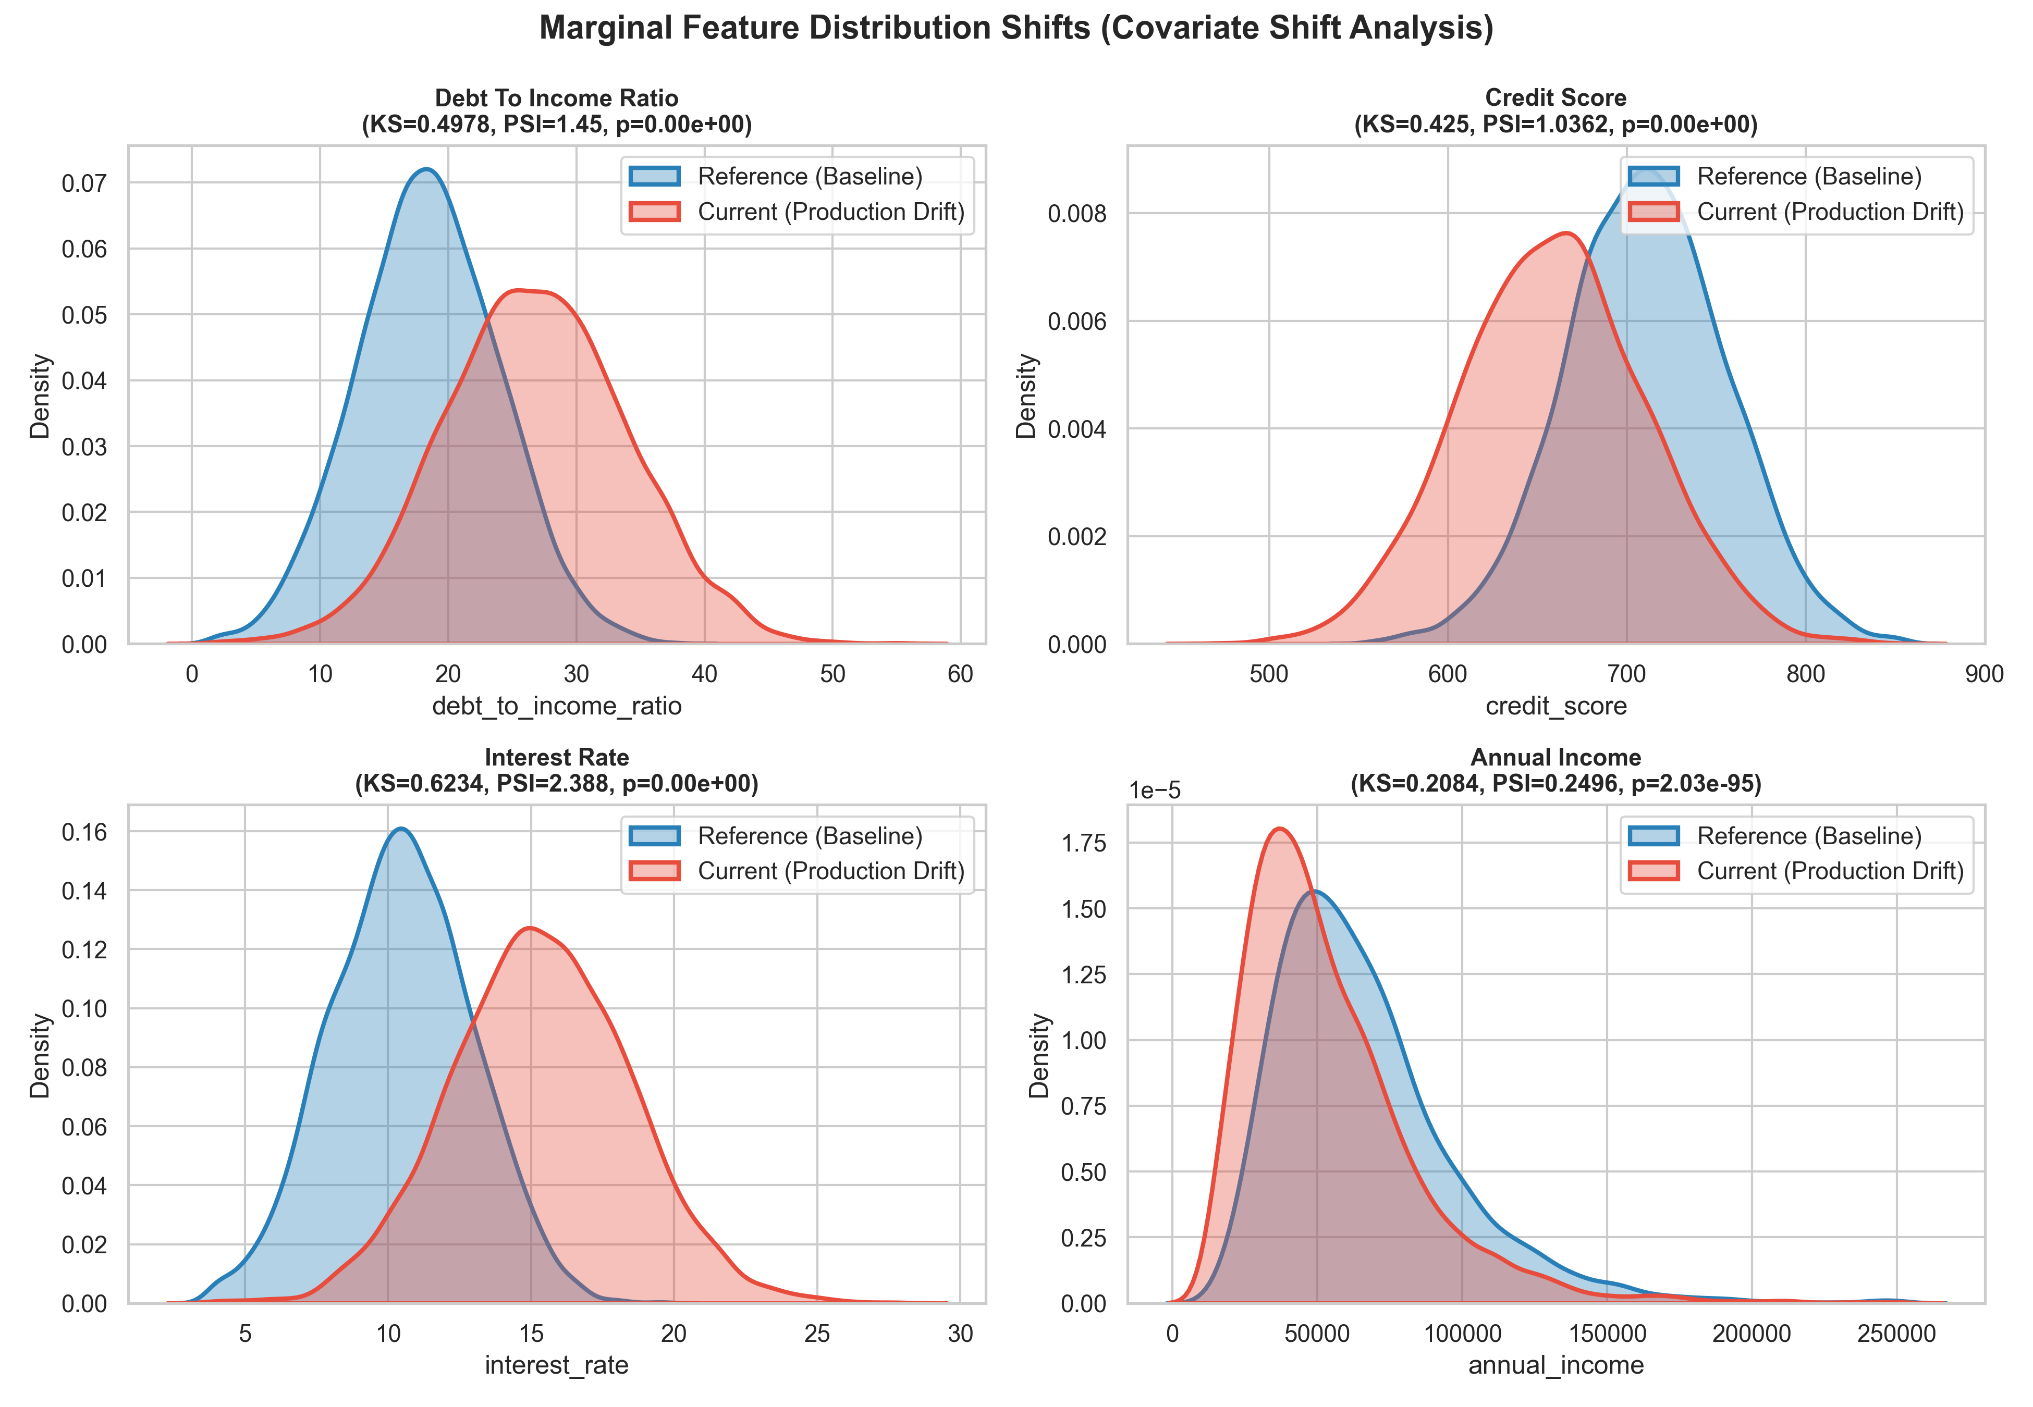
Figure 3: Marginal Feature Distribution Shifts (Covariate Shift Analysis)
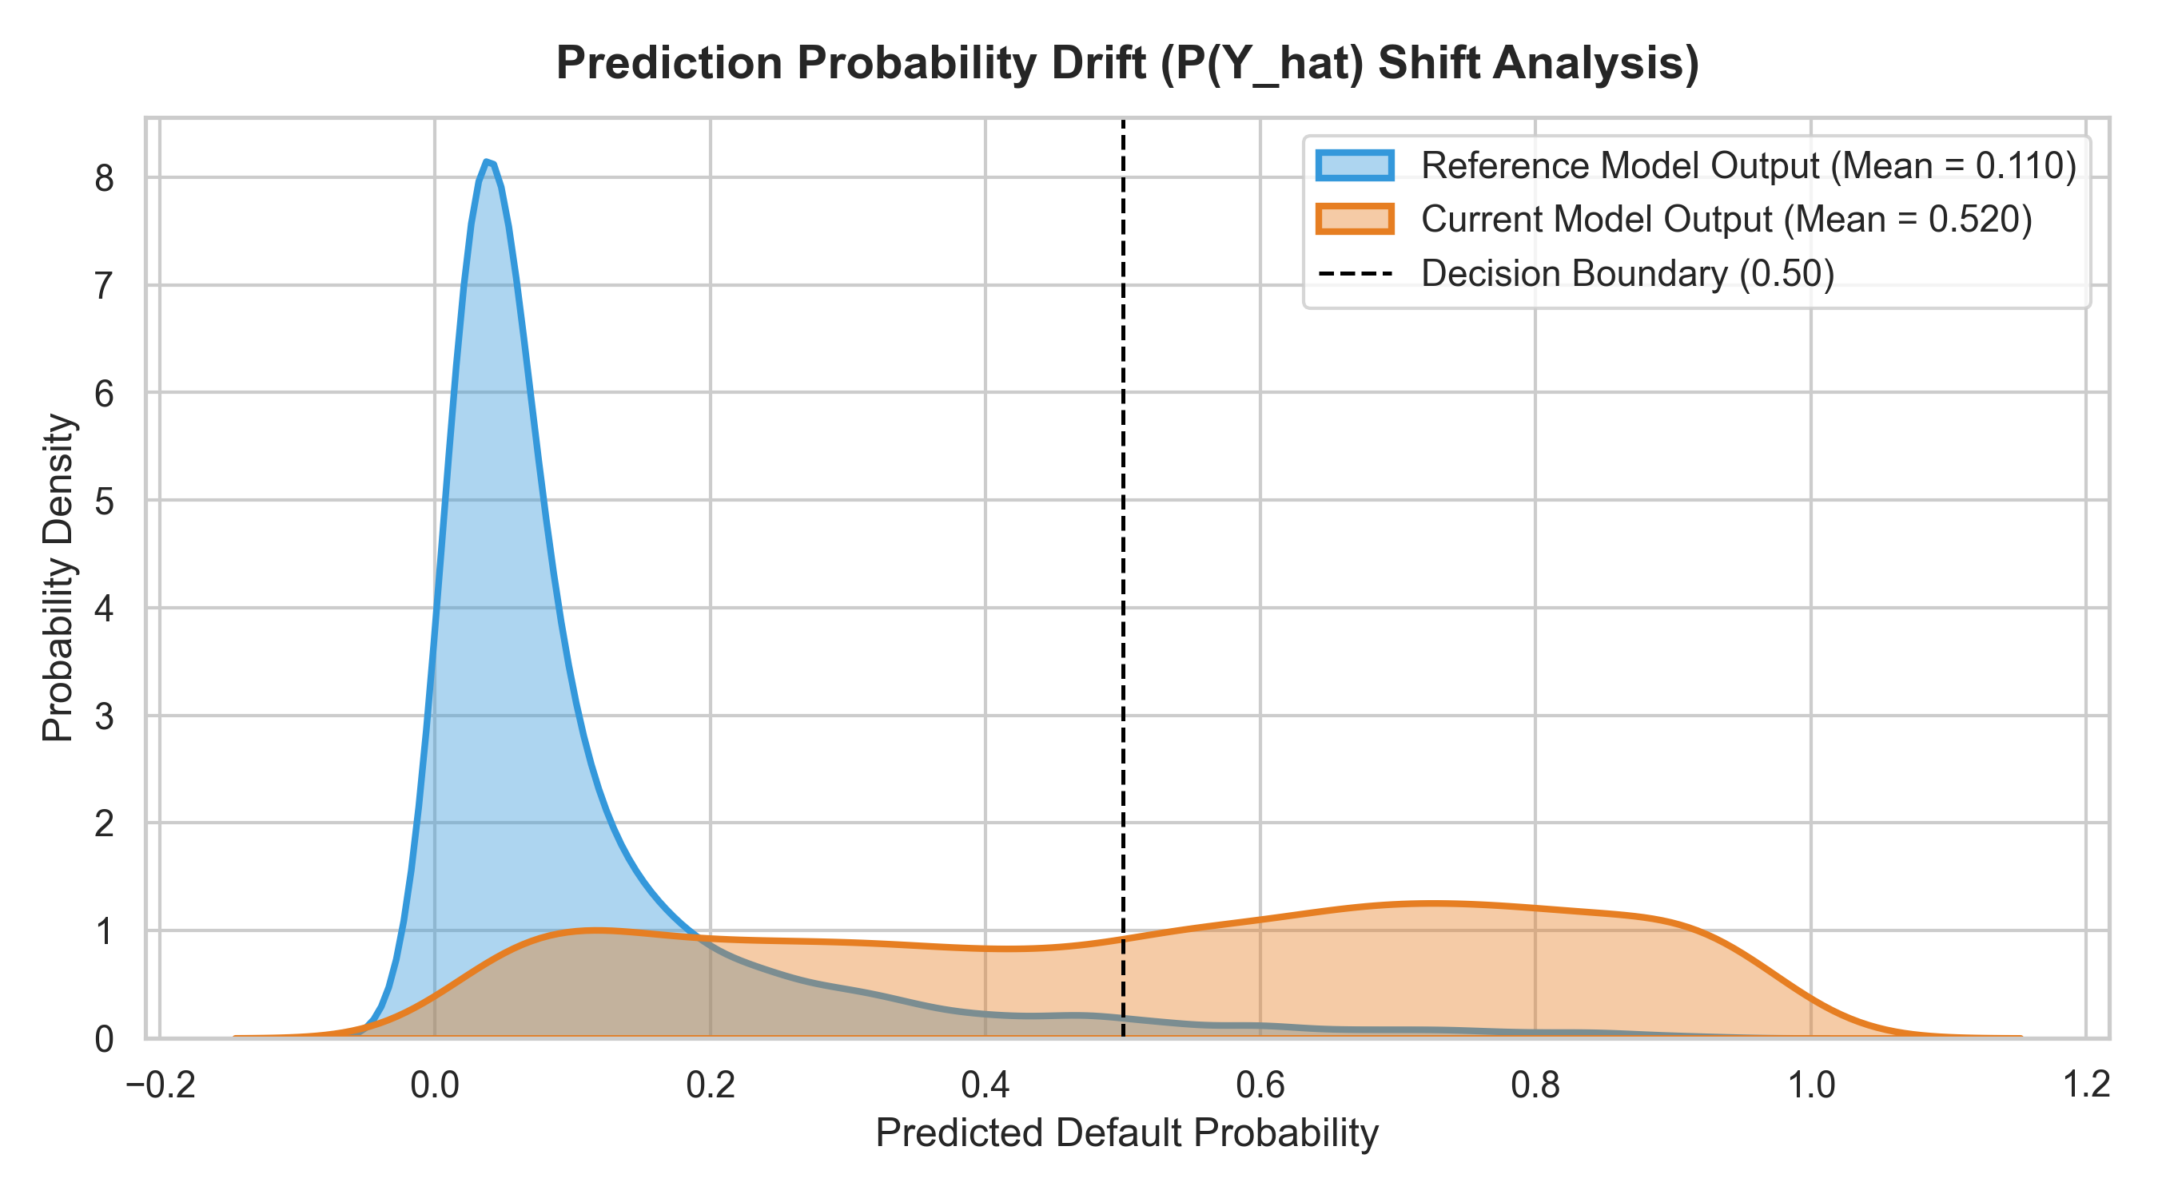
Figure 4: Prediction Probability Output Distribution Drift (Reference vs Production)
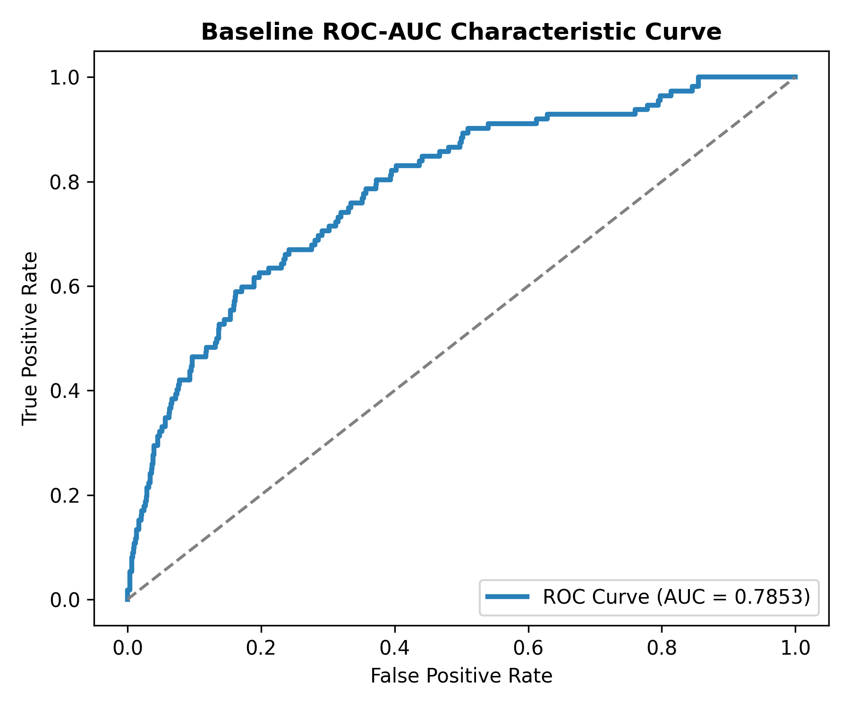
Figure 5: Baseline Classifier ROC-AUC Characteristic Curve
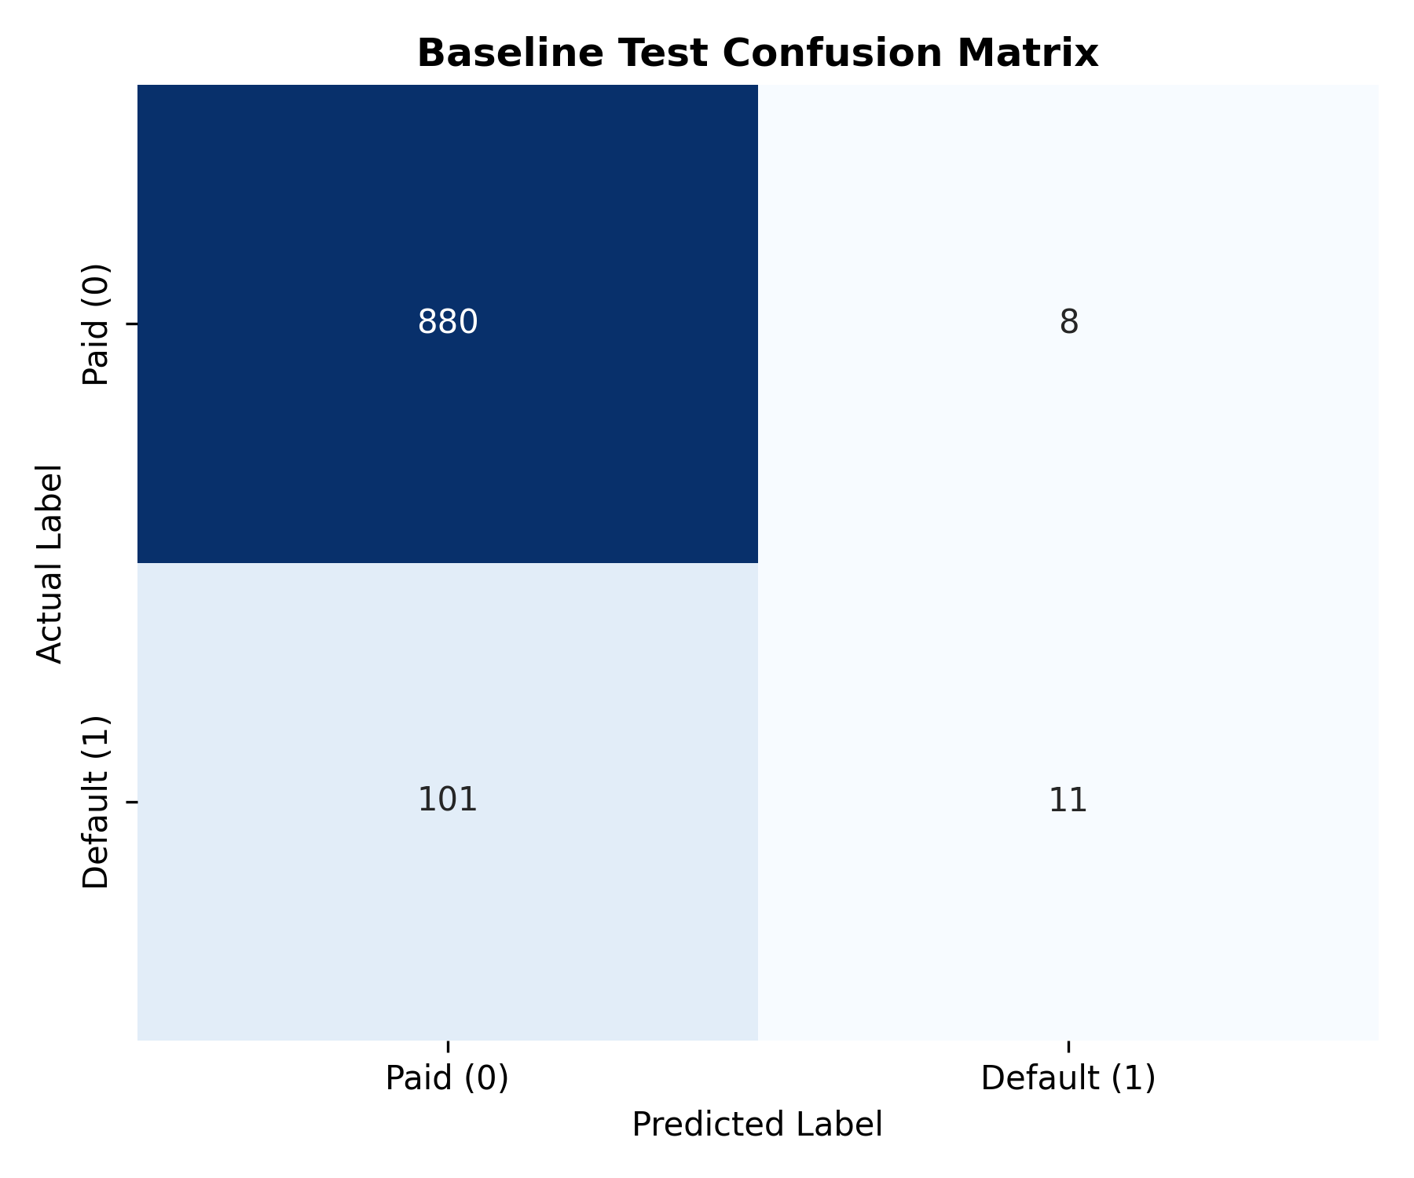
Figure 6: Baseline Classifier Confusion Matrix

